📚🔭Tools to enumerate NTDS Database With Kali 🐉

Intro

As we saw on the introduction of this section we can enumerate the NTDS Database that the domain controller has, even without an elevated user privs on the domain, through the LDAP protocol we just need to use the credentials of a legitim domain user to enumerate remotely all that information.

We can use a lot of tools to enumerate NTDS Databases and in this section we are going to see how to use some tools to do that.

👾Netexec/🐙Crackmapexec
NetExec (formerly known as CrackMapExec) is a post-exploitation and enumeration tool that allows you to interact with common Windows networking services such as SMB, WinRM, RDP, and of course, LDAP.

When connected via LDAP, NetExec allows us to enumerate key information from the Active Directory domain (NTDS) in the Domain Controller database without using SMB or executing remote commands. Of course we will need credentials of a legitim domain user, in case of bad configuration, we can use an anonymous user like ‘guest’ user without password. If ports 389 and 636 are open, we can enumerate LDAP

Among the things we can enumerate, specifying the DC IP address, are:

👥 Domain user enumeration (--users)

netexec ldap 10.10.10.5 -u Username -p Password --users

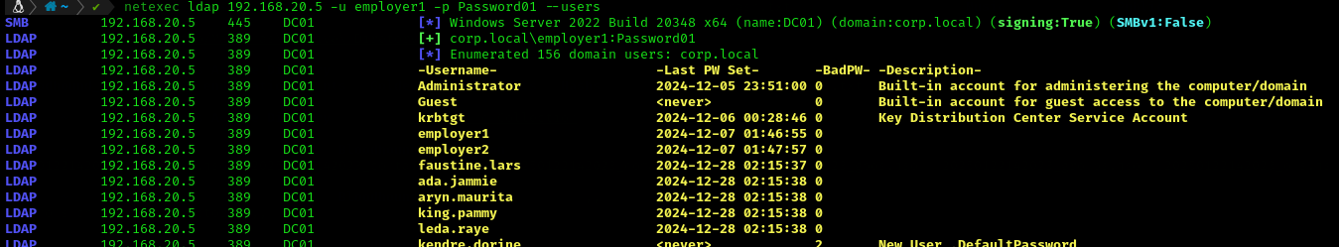

👨‍👩‍👧‍👦 Group enumeration (--groups)

netexec ldap 10.10.10.5 -u Username -p Password --groups

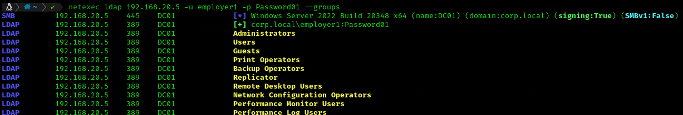

Something interesting is that we can enumerate that information using SMB protocol, in some cases with better results. For example if we enumerate groups, specifying the SMB protocol, not only do they show us the groups that are in the domain, but also how many members belong to them. 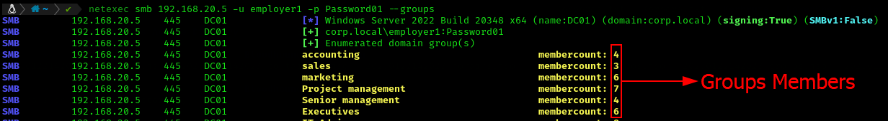

We can also list the domain's password policy with the --pass-pol flag. 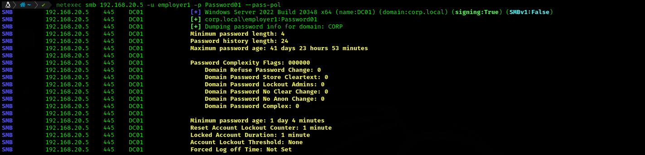

With this information we can design more realistic brute force attacks that do not endanger the productivity of the environment we are auditing.

Another parameter that we can use is --rid-brute that It is used to perform a user enumeration based on RID (Relative Identifier). This parameter tells NetExec to perform a RID brute force to discover which users exist on the system, based on SMB responses. This parameter is very useful to this kind of enumeration without the need for valid credentials whenever the system is not properly configured to prevent this type of enumeration.
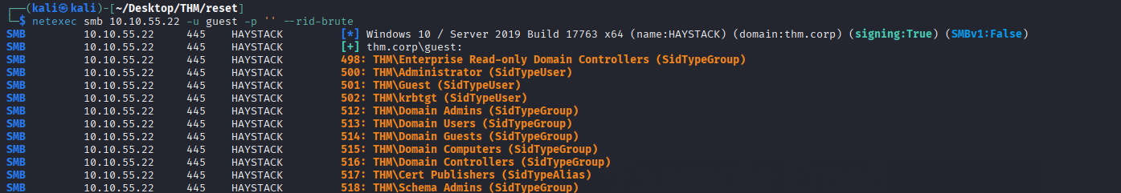

It is very important to mention that this technique can generate logs or alerts in monitoring systems such as IDS and EDR

It's critical to use all of these methods when enumerating a domain, as enumeration with one protocol is likely to work but not with the other, and vice versa. Enumeration is key.

🖥️⚡Pywerview

Intro

Pywerview is a tool writing in python for enumeration using LDAP protocol. This tool is very similar to Power View, in that it will allow us to enumerate the NTDS database with one big difference : that we can use Pywerview to enumerate from our attacker machine.

To use Pywerview we will need credentials from a domain user.

This tool cames pre install on Kali Linux 🐉and Parrot 🦜systems and it will be use it by terminal command line.

🖥️🔨⚡ Pywerview on action

The command to use pywerview will consist of calling the tool “pywerview” then the command that we will use to enumerate, for example “get-netuser”, next we have to use the username with the parameter “-u user”. The next step is put the DC IP address “--dc-ip 192.0.0.5” and finally the password with “-p password:D”

There some examples of commands that we can use to enumerate NTDS database

pywerview get-netuser -u Username --dc-ip 192.0.0.5 -p Password

This command will dump information about all domain users

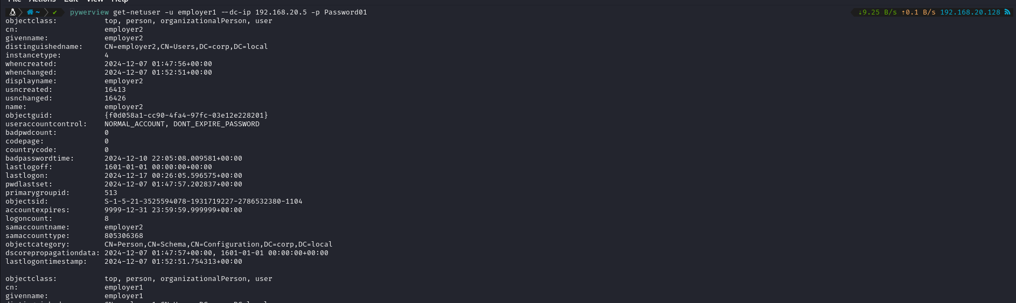

pywerview get-netdomaincontroller -u Username --dc-ip 192.0.0.5 -p Password

This command allows us gather information about the domain controller

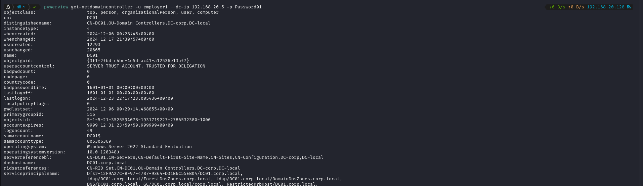

There are just two examples of what we can do with pywerview. Of course, it has a lot of functionality that we can use to enumerate a domain and that we can use according to what we want to enumerate in the domain

Conclusions

As we have seen, pywerview is a very interesting tool that we can use if we don't have access to a domain computer or if we just want to use an alternative tool.

If we want more info about all commands that we can use, we just have to use the the command pywerview -h

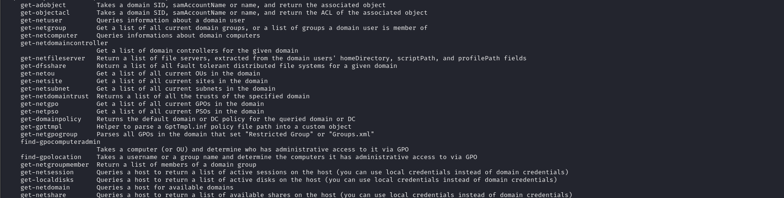

📟 Ldapsearch

Intro

Ldapsearch is a tool that allows us to interact with a database using the LDAP protocol and we use it to interact with the NTDS Database that DC has.

This tool cames pre install on Kali Linux 🐉and Parrot 🦜systems and it will be use it by terminal command line

📟👨‍👩‍👦‍👦 Ldapsearch on action

Ok, let’s see some commands that we can perform with LDAP search.

ldapsearch -x -H ldap://10.10.10.5 -D ‘DOMAIN\Username' -w 'Password' -b "DC=domain,DC=local"

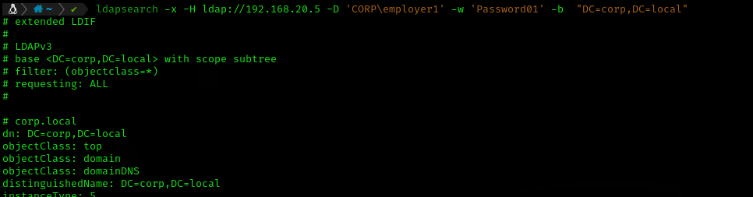

When we successfully perform this command we will see that we received an enormous output, because ldapsearch is dumping all the information that this NTDS database has, user, groups, gpos, computers… etc.

But if we just receive a specific information we just have to add the flag CN= on the -b part followed by that information that interests us. For example, if we are interested of dump all domain user will be something like:
-b "CD=UsersDC=domain,DC=local".
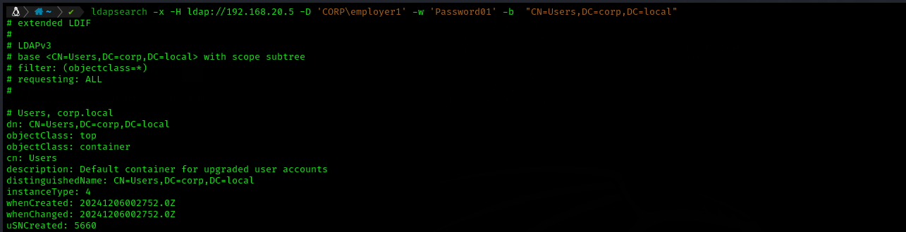

And if we are interested on a particular user we can add that username adding "(sAMAccountName=user.name)"
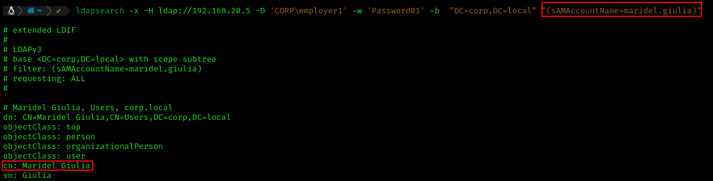

If we what enumerate de computes on the domain we can add "CD=Computer”:
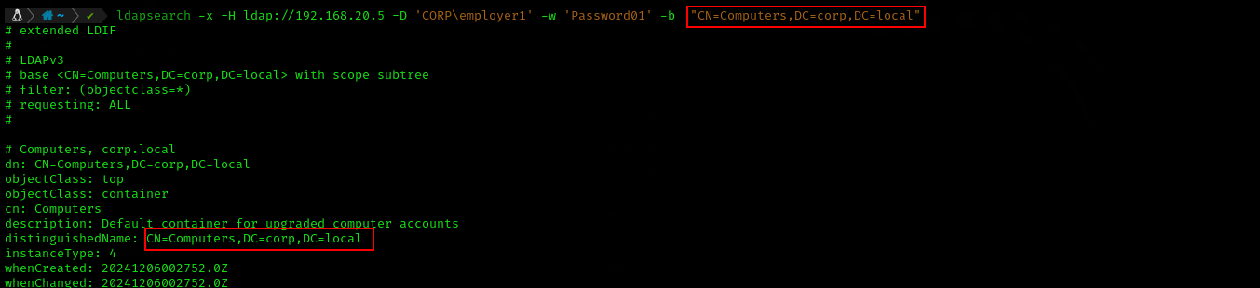

And if we what to enumerate a particular group and its members, we can do it adding the flag "CD=GroupName,CD=Users,”

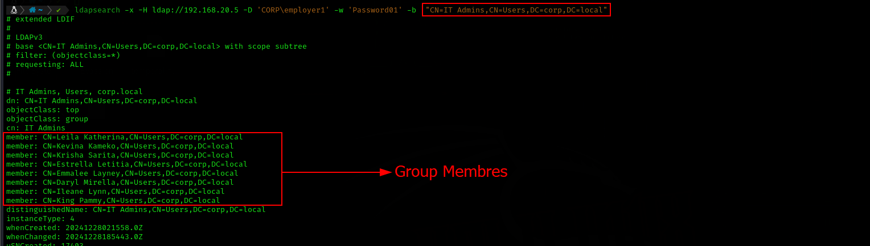

And we can more

Anonymous enumeration

ldapsearch -x -H ldap://10.10.10.5 -D ' ' -w ' ' -b "DC=domain,DC=local"

ldapsearch -x -H ldap://10.10.10.5 -b "DC=domain,DC=local"

We can perform this command to see if the domain allows enumeration by an Anonymous user. An anonymous enumeration is unlikely to be carried out, but it never hurts to try.

Conclusion

There are some information tools that we can use to enumerate a domain via NTDS database through LDAP and other protocols from our attacker Machine.

